**Shikhar Giri**

**TARGET MARKET:**

I wanted to do a movie poster targeting crime drama fans, ages 18+ years old, both genders.

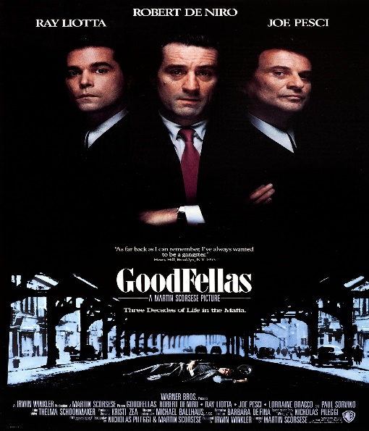 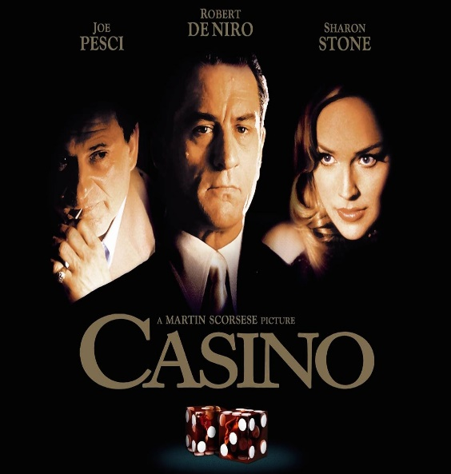

**COMPETITION RESEARCH:**

After researching the competition, the two competitors I discovered would be the movies Goodfellas and Casino. Both movies are within the crime drama genre and contain similar elements to my movie concept. While researching how to successfully outcome these two movie posters, I researched article by Chris Jones and designer on the elements of a great movie poster designing process, as well as an article by the Web designer depot.

One aspect Jones noted is that a poster must grab the attention of the audience who are passed by it. On this basis, I decided to use an image from out in space depicting bright, vivid colors that will easily stand out and will encourage for a close look. Some other things that Jones pointed out are iconography, or showing without telling as he puts it, and creating interest. Also, the imagery of a major plot point is used to gain attention in the most effective movie posters. (Jones 2012)

Using those key ideas, I decided a scene to display these elements showings just enough of what movie is related. Web designer depot also says that the poster must be balanced and that and it is very crucial to know how to create a well-balanced design to be a successful designer. (2018)

**RESEARCH REFERENCES:**

Jones, C. (2012, November 14). How to design a movie poster – top ten tips to grab the eye of a sales agent, distributor or audience member. Retrieved from <http://www.chrisjonesblog.com/2012/11/how-to-design-a-movie-poster-–-top-ten-tips-to-grab-the-eye-of-a-sales-agent-distributor-or-audience-member.html>

7 Elements of a Great Movie Poster Design. (2018, February 07). Retrieved from <https://www.webdesignerdepot.com/2011/02/7-elements-of-a-great-movie-poster-design/>

**ANALYTICAL REASONS:**

I used an outer glow effect in the moon to add a new dimension to my moon layer. I also used the outer glow effect the lamp layer to increase the brightness of the light and make it realistic.

I used two smart filters layered as Scene and the title layer to develop nondestructive working habits since I can go back to filter and change the setting later.

I used several masks to preserve pixels on a layer even as I revealed only certain parts or to apply a filter to only certain pixels on a layer.

I did use the high-resolution photo downloaded from the copyright free site and some I did capture myself. To ensure the photo was high resolution, I used to photo over 3800 pixels wide as I know for A4 size quality I need a minimum of 3000px.

**IMAGES SOURCES:**

<https://www.pexels.com/photo/brown-building-with-yellow-lights-at-night-1600151/>

<https://www.pexels.com/photo/photo-of-full-moon-975012/>

<https://images.unsplash.com/photo-1512135159328-0fa33838237b/>